**동국대학교 산업시스템공학과 2016112591 안성준**

**데이터베이스 과제 Lab Database 풀어 보기**

**1.**

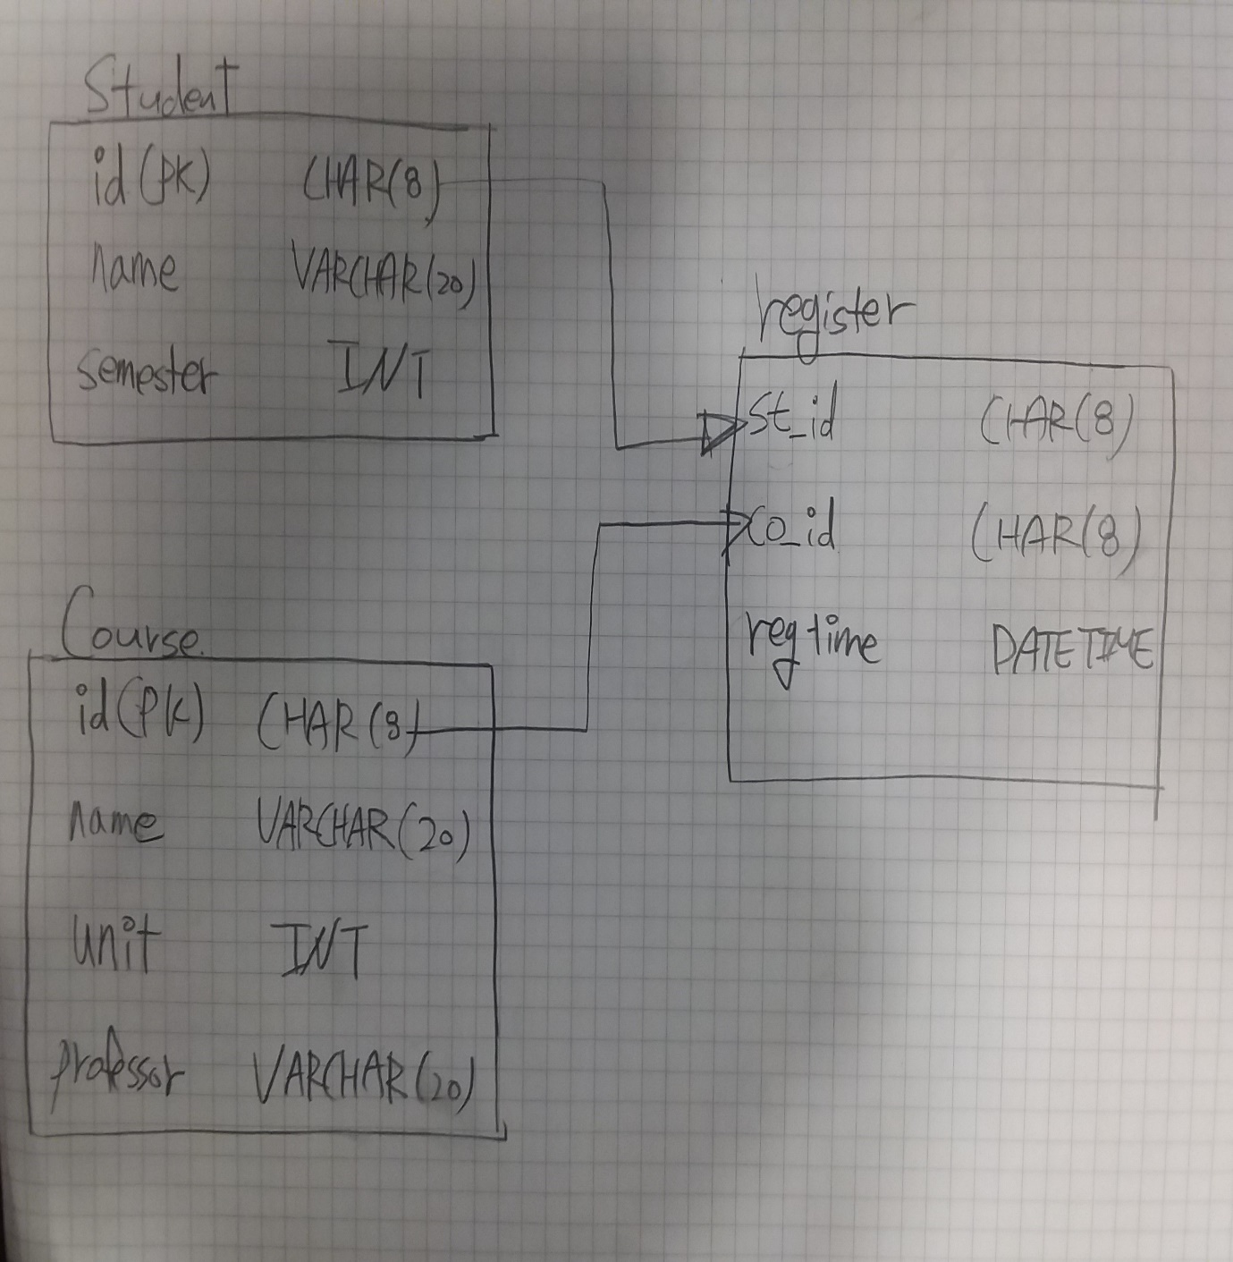

**2.**

CREATE DATABASE dgu;

**3.**

CREATE TABLE student

(id CHAR(8), name VARCHAR(20), semester INT, PRIMARY KEY(id));

CREATE TABLE course

(id CHAR(8), name VARCHAR(40), unit INT, professor VARCHAR(20), PRIMARY KEY(id));

CREATE TABLE register

(st_id CHAR(8), co_id CHAR(8), regtime DATETIME);

**4.**

INSERT INTO student VALUES (‘20190101’, ‘가나다’ ,3), (‘20190102’, ‘나한가’ ,2), (‘20190103’, ‘나두야’, 2), (‘202000101’, 가운데’, 1), (‘20200102’, ‘김한나’, 1), (‘20200103’, ‘유명한’, 1);

**5.**

INSERT INO course VALUES (‘S01’, ‘데이터베이스’, 3, ‘최교수’),(‘S02’, ‘국어’, 2, ‘강교수’), (‘S03’, ‘영어’, 2, ‘James’), (‘S04’, ‘자바’, 3, ‘최교수’), (‘S05’, ‘수학’, 2, ‘수학교수’);

**6.**

INSERT INTO register

(SELECT st.id, co.id, NOW() FROM student st, course co

WHERE st.name=’김한나’ AND co.name = ‘데이터베이스’);

**8.**

INSERT INTO register

(SELECT st.id, co.id, NOW() FROM student st, course co

WHERE st.name = ‘김한나’ AND( co.name=’국어’ OR co.name=’영어’));

**10.**

INSERT INTO register VALUES (20200103,’S05’, NOW()), (20200103,’S01’NOW());

**11.**

SELECT c.name as 교과목, c.unit as 학점, c.professor as 교수

FROM student s, register r, course c

WHERE s. name = ‘김한나’ AND s.id=r.st_id AND c.id=r.co_id

ORDER BY c.name;

**12.**

SELECT s.name as 이름, COUNT(*) AS 과목수, SUM(c.unit) AS 학점

FROM studet s, register r, course c

WHERE s.id=r.st_id AND c.id=r.co_id

GROUP BY s.name;

**13.**

DELETE FROM register

WHERE st_id = SELECT( id FROM student WHERE name = ‘김한나’)

AND

co_id = SELECT( id FROM course WHERE name = ‘국어’);

**14.**

UPDATE student

SET semester=semester+1

WHERE id IN (SELECT DISTINCT st_id

FROM register);

**15.**

DELETE FROM course

WHERE id IN (SELECT co_id

FROM register

GROUP BY co_id HAVING COUNT (*) < 5)

OR NOT EXISTS (SELECT co_id FROM register r WHERE id = r.co_id);